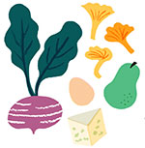

September Member Specials

BobAli Hummus, Pestos and Tapenades - $1 off (reg. $7/ea) or 3 for $15

Ildiko Jewelry – $5 off Any Two Pieces of Jewelry

Marie’s Guilt Free Bakery– 10% off purchases $20 or more

Nice Pops – $1 off Any Popsicle!

Rockweld Farms – Chicken Breast, boneless, skinless – Buy Two packages Get 3rd One FREE!

